An introduction to DUNA
Feb 2026
ETG

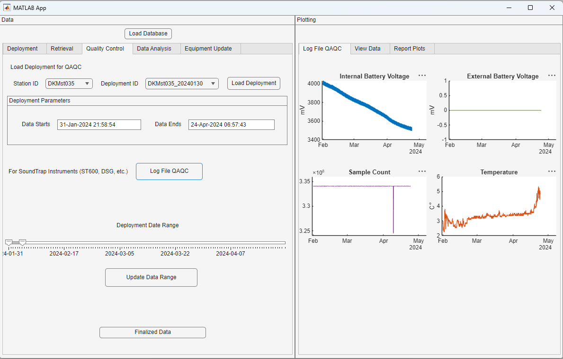
Contents
Introduction 2
Opening DUNA 2
Entering deployment metadata 2
But Emily, what if I get this error? 5
Retrieval Metadata 6
What’s going on behind the scenes? 8

Introduction
DUNA (Danish Underwater Noise Aggregate, or ‘to boom’ in Old Norse) is a Matlab app used in conjunction with underwater noise collection in Danish waters. DUNA allows for the organization of associated metadata, visually assessed quality control checks, and the ultimate processing of raw wav data into decidecades into uncalibrated pascals and calibrated decibels. Decibels are saved as structs, timetables, and (eventually) h5 files in compliance with the ICES underwater noise database format.

Opening DUNA
A stable version of DUNA can be found on github: https://github.com/etgriffiths/DUNA
However, in this workflow we are going to work with the version on the O drive, so you can see how it interacts with the surrounding directories. It is found here:
O:\Tech_MSFD-deskriptor11-Danmark\Monitering\Analysis\DUNA
Open Matlab and then open the DUNA app from the Matlab interface, it just works better! Once the app interface is opened, hit the Run/Play button at the top. Sometimes the GUI opens oddly. If you resize it, all of the app should shift into focus.

Entering deployment metadata
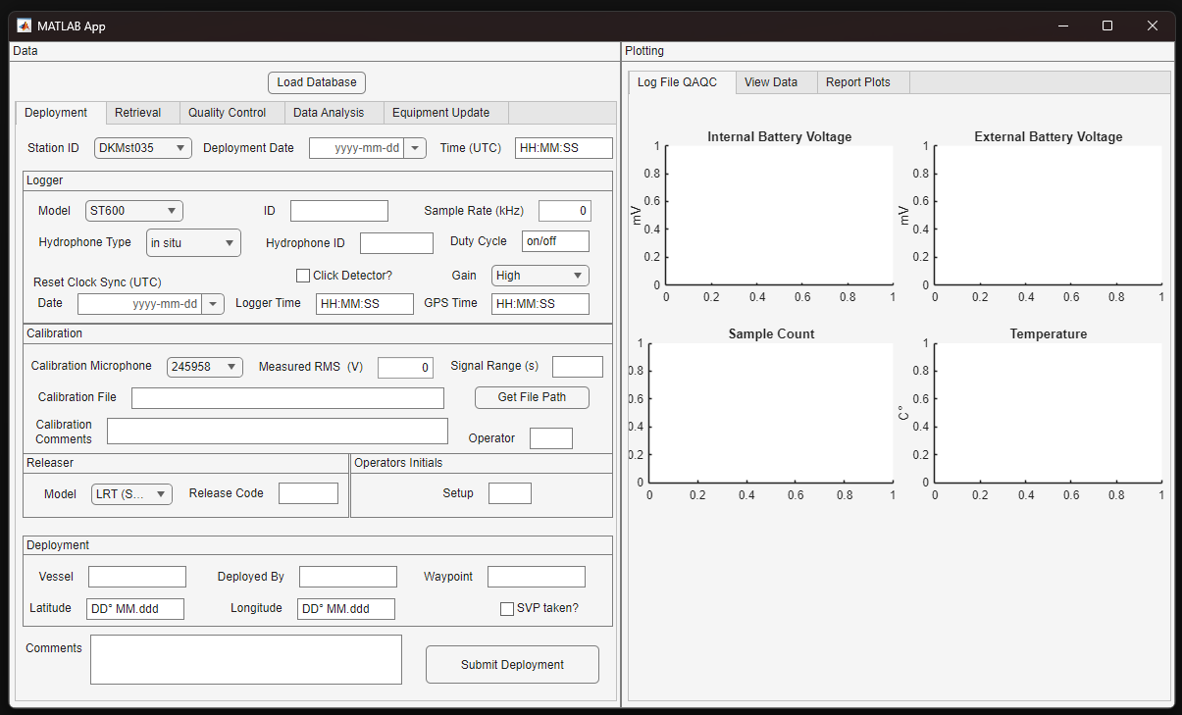
The first thing you need to do for this app is to load the database, at the top of the left column. The app WILL NOT work without it. Click that, and then navigate to the location of the active database, found here: O:\Tech_MSFD-deskriptor11-Danmark\Monitering\Data\DK_NoiseMonitoringMetatadata_v5.sqlite3
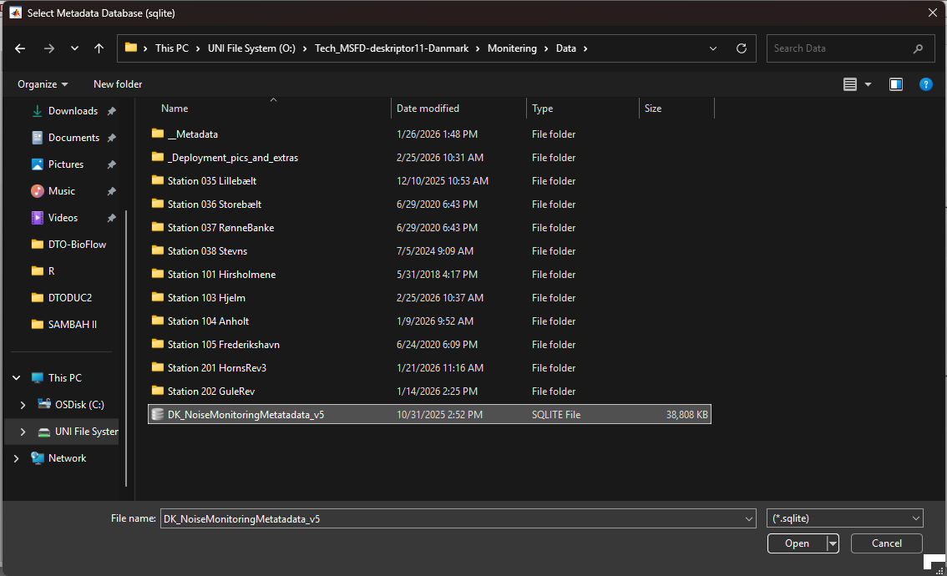
Once the app is database is linked, you can start to add data. Coordinates can be added in the format suggested, or decimal degrees. I think my function CAN take other types, but I can’t remember at the time of this writing.
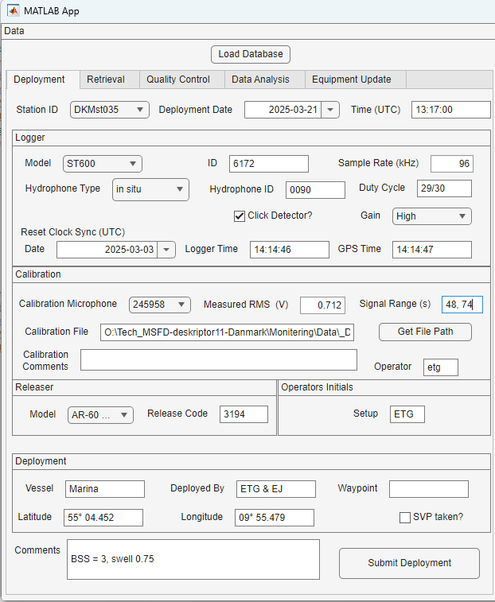

Once you hit Submit Deployment, the app will have a think, and then give you a review of the information you just inputted. Check to make sure that it is correct. Note that it automatically calculates the lat/long in decimal degrees and the cliplevel for you, and check to make sure that looks correct. If it doesn’t, you’ll need to look at the data manually. Otherwise, if the data is correct, Hit Yes, if not, hit no and then change it!
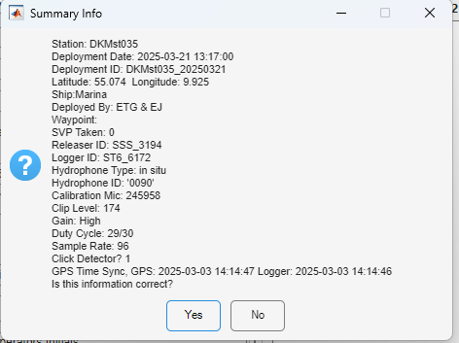

But Emily, what if I get this error?
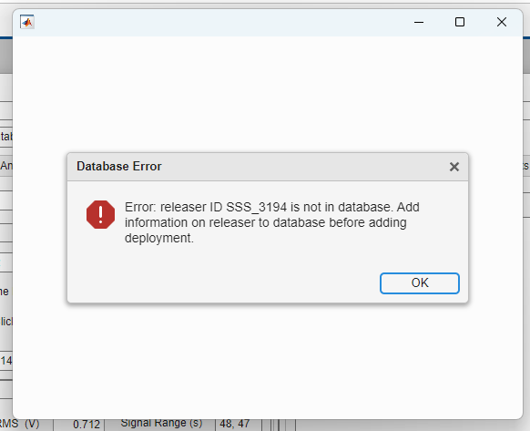
No worries! That just means that the one of the piece of equipment used in this deployment wasn’t already registered in the database. If this is the case, when the Summary Info tab pops up, hit no, and then switch over to the Equipment Update tab:
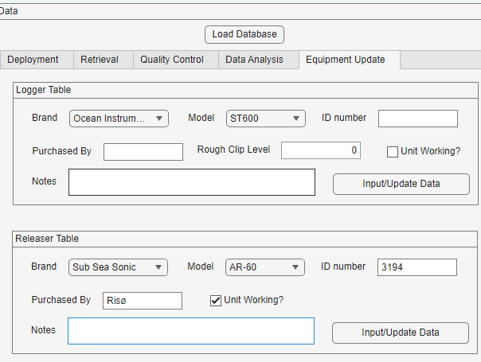
Hit Input/Update Data, and it will add the instrument to the appropriate table in the database. After you hit the button, you can return to the Deployment tab, and hit submit again. This time you should not get this error, and, if your information for the deployment is correct, you can submit the deployment to the database.
In general, it is a good idea to keep an eye on the Matlab window. There is progress text as things are being save there (sometimes) and if the app produces an error, there will be more information there.

Retrieval Metadata
For the retrieval tab, it is mostly the same. Input the information you have. However, it is important that you do NOT log data in this table until AFTER you have decompressed the wav files. Many of the functions that are set into motion after this form is filled out rely on being able to access the wav files, to start logging and organizing the data present for each deployment.
Once you have selected your Station ID, be sure to use the drop down menu and select the correct Deployment ID. This will be your Station ID (for example, DKMst035 for Lillebælt), underscore, and then YYYYMMDD of the deployment date. So in the example above, it would be DKMst035_20250321. By selecting this deployment ID, it links all the data together across the database. This is true for ALL tabs in DUNA.
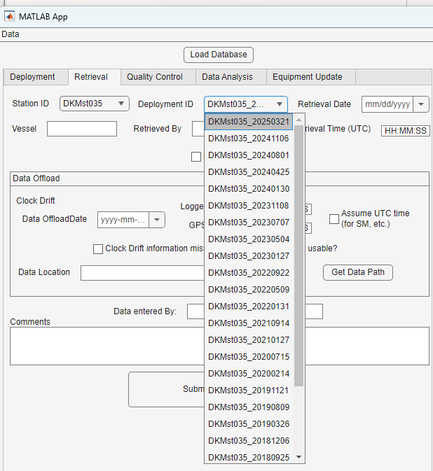
In this tab, you can note if the deployment is Lost. However, you can also use this tab to overwrite that if the logger is found later on.
It is most important to document the clock drift it is available. If it is, when you Submit Retrieval will automatically account for clock drift in the metadata.
When you hit submit, a similar review window will pop up that you should review. Once you hit yes, another pop up window will prompt you to pick the calibration file you want associated with this deployment. All of the calibrations associated with the logger used in the deployment will pop up, listed by date. In general, you should use the calibration date most closely associated with the deployment date. However, for whatever reason, this allows you to pick a different calibration if needed.

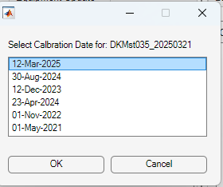

What’s going on behind the scenes?

So at this point, the metadata you have added goes into the appropriate tables in the database:
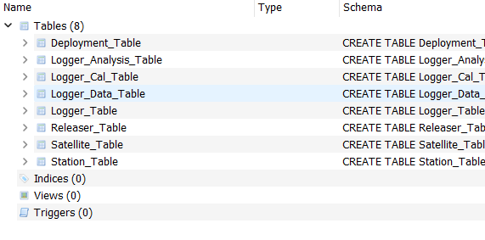
This happens throughout the process. Open the database and poke around.
However, the metadata is also stored in a Matlab .mat file, organized here: O:\Tech_MSFD-deskriptor11-Danmark\Monitering\Data\__Metadata\__allMetaData
This part of the process is a bit broken, as the app is not as good as keeping the .mat files updated as it is the database at this time. This is one of the processes I am still smoothing out. So if something incorrect goes into a metadata .mat file, it needs to be fixed manually.

Variables stored in the .mat file are:
>> who
Your variables are:
CaliFile SVPtaken hpID syncGPSslut
ClickDetectorOn SampRate hpType syncGPSstart
ClipLevel Vrms loggerID syncLOGslut
Comments calMicSerial loggerType syncLOGstart
DTslut clockdriftinfo mooringLat toneRange
DTstart dCycle mooringLon uncroppedData
Datetime_Deployment dataPath mooringOut usableFiles
Datetime_Retrieval depShip releaserID waypoint
Deployed_by deplogTable retShip
Deployment_ID depwavFiles sensVPa
QualityResults gain sensdB
Retrieved_by good station

In this list, there are 6 variables I want to highlight.
deplogTable Table. This stores all of the information extracted from the log.xml files, including battery usage and temperature. Added to this table is also the datetime column that absolutely has the correct UTC time for each file, accounting for clock drift. This is after the app has looked for a) if UTC time is available, b) what timezone the logger thinks it is, and c) user input on the timezone. Other variables that create this variables are in other tables.
depwavFiles Table. General file information about the wav files added from Matlab. Added to this table are two columns: originalDate (the original date associated with the filename) and clockDriftDate (date accounting for clockdrift, if that information is available).
QualityResults Struct. Results for the many QA/QC tests we run on the data, with the index (Q_ALL) of what files do not meet the criteria. It also includes the filesdata Table, which is a list of the files from the depwavFiles table that have passed the QA/QC tests.
uncroppedData Table. All files in the associated data directory.
usableFiles Table. Files that are processed into DDEC. Removes files which failed the QA/QC and files manually filtered by the user based on the QC plots (see Quality Control tab).

Quality Control
In the Quality Control tab, you can load the data for a given deployment, and start analysis! When you load a deployment, a date range will pop up. This date range is taken from the first file available for analysis after deployment, and the last file available before retrieval. Hit ‘Log File QAQC’, which will run through all of the log.xml files associated with your deployment.

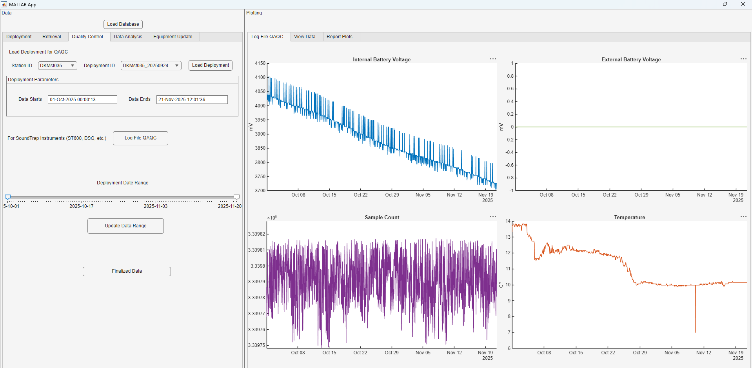
You will get 4 plots that show you data from the battery usage, logger temperature, and sample count. Using the Date Range toggle, you can scroll around and look for data that should be removed at either the start or the end of the deployment. After you are comfortable with a date range, click ‘Update Data Range’ and then ‘Finalize Data.’ This will create the ‘usableFiles’ table in Matlab seen in the previous section.

Decidecade Analysis
And here I will stop! Seriously, if you get to this point either follow the steps, or just reach out!

